Vocabulary N° 1
“Parts of the Body”
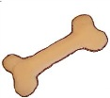
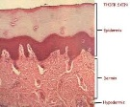
Our bodies are made up of bones and skin .
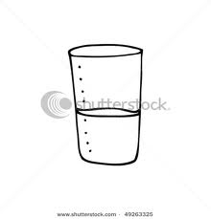
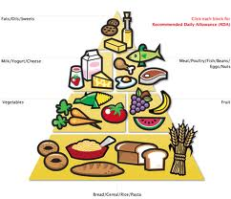
They need food and water for its correct functioning.

Some parts of the body are: head, legs, hand, eye, mouth, nose, neck, ear, hair.

